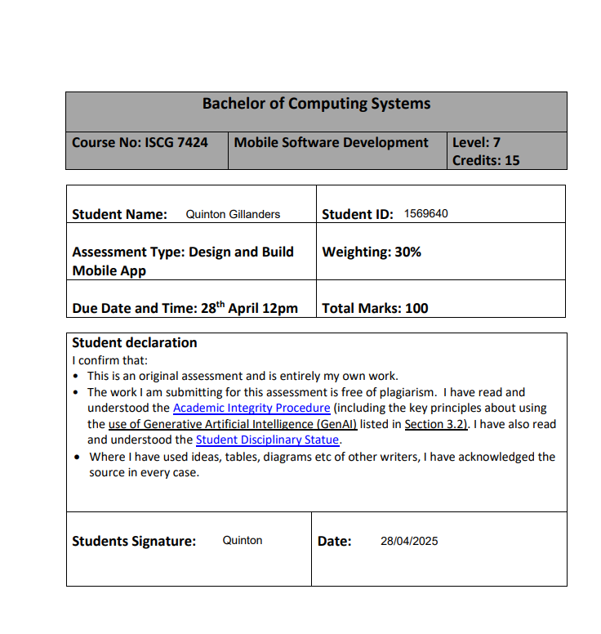

# Wireframes

# References

I had/still have bugs such as:

Login screens not working correctly, saying that a user does not exist even after clicking on register saying, “Registration successful” (FIXED)

Room database crashing the app due to incorrect database versions. (FIXED)  
  
SearchView not displaying results after pressing enter with a toast message saying, “No deals found, check back later!” (FIXED)

Xml layout (background) in Featured deal screen not covering the whole screen (FIXED)